Enterprise ServiceNow IT Support Lab
IT Service Management (ITSM) Using ServiceNow
Technical Deployment Guide
Author: Deividas Talocka
Version 1.0
August 2026

Contents
Executive Summary 3
1. Introduction 4
1.1 Project Overview 4
1.2 Project Objectives 5
1.3 Scope 5
2. Lab Environment 5
2.1 Infrastructure 5
2.2 Technologies 6
2.3 Intended Audience 6
3. Solution Overview 6
3.1 Enterprise Environment 6
3.2 Support Workflow 7
3.3 Project Workflow 7
4. Implementation 7
Step 1 – Create the IT Support Technician Workstation (IT01) 7
Step 2 – Configure the IT Support Workstation 9
Step 3 – Join the IT Support Workstation to the Domain 10
Step 4 – Create a ServiceNow Developer Account 11
Step 5 – Request a Personal Developer Instance (PDI) 12
Step 6 – Access and Validate the ServiceNow Instance 13
Step 7 – Familiarise with the ServiceNow Interface 14
5. IT Support Scenarios 16
5.1 Incident INC0010006 – User Unable to Sign In 16
5.2 Incident INC0010008 – Password Reset 20
5.3 Incident INC0010010 – Shared Folder Access 24
5.4 Incident INC0010012 – New User Account Creation 29
5.5 Incident INC0010013 – Software Installation 34
6. Knowledge Management 39
7. Conclusion 40
8. Lessons Learned 40

Executive Summary
This document presents the implementation and validation of a ServiceNow Personal Developer Instance (PDI) configured to simulate a realistic enterprise IT Service Desk environment.
Building upon the Enterprise Active Directory Infrastructure Lab, this project demonstrates how ServiceNow is used to manage, investigate and resolve common IT support requests within an enterprise Windows domain. Rather than focusing solely on configuring the platform, the project simulates the day-to-day responsibilities of an IT Support Analyst by handling realistic incidents, service requests and user administration tasks.
The implementation demonstrates the complete support lifecycle, from ticket creation and categorisation through investigation, resolution and closure. Common enterprise scenarios such as password resets, account lockouts, new user provisioning, security group management, shared folder permissions and software requests are completed using the existing Active Directory environment.
Each activity is documented with supporting screenshots and technical explanations to demonstrate practical experience with both Windows infrastructure administration and IT Service Management.

1. Introduction

1.1 Project Overview
ServiceNow is one of the world's leading IT Service Management (ITSM) platforms and is widely used by organisations to manage incidents, service requests, knowledge management and day-to-day IT support operations.
The purpose of this project is to demonstrate how ServiceNow can be used alongside an existing Windows Server Active Directory environment to support enterprise users through structured IT support processes.
Unlike the previous project, which focused on building enterprise infrastructure, this implementation focuses on operating and supporting that infrastructure using ServiceNow. Realistic support requests are created, investigated and resolved using the Active Directory environment previously deployed.
Together, both projects demonstrate the relationship between enterprise infrastructure and enterprise IT support.

1.2 Project Objectives
The primary objectives of this project are to:
- Deploy and configure a ServiceNow Personal Developer Instance.
- Configure a realistic enterprise IT support environment.
- Create users, assignment groups and support workflows.
- Manage incidents and service requests using ServiceNow.
- Resolve support requests using the Enterprise Active Directory Infrastructure Lab.
- Produce professional technical documentation supported by screenshots.

1.3 Scope
This project focuses on ServiceNow IT Service Management (ITSM) functionality most relevant to entry-level IT Support and Service Desk roles.
The implementation includes incident management, service requests, assignment groups, user administration, knowledge management and reporting while using the previously created Active Directory environment to complete technical support tasks.
Advanced ServiceNow modules such as ITOM, HRSD and CSM are outside the scope of this implementation.

2. Lab Environment

2.1 Infrastructure
Component | Specification
Service Management Platform | ServiceNow Personal Developer Instance
Domain Controller | Windows Server 2025 (DC01)
Client Computer | Windows 11 Enterprise (PC01)
Hypervisor | VMware Workstation Pro
Operating System | Windows 11
Browser | Google Chrome

2.2 Technologies
- ServiceNow
- IT Service Management (ITSM)
- Windows Server 2025
- Active Directory Domain Services (AD DS)
- Windows 11 Enterprise
- DNS
- Group Policy
- VMware Workstation Pro

2.3 Intended Audience
This documentation has been produced for recruiters, hiring managers and technical professionals seeking evidence of practical experience using ServiceNow to support enterprise Windows environments.

3. Solution Overview

3.1 Enterprise Environment
The solution combines the Enterprise Active Directory Infrastructure Lab with a ServiceNow Personal Developer Instance to simulate a modern enterprise IT support environment. ServiceNow acts as the central service desk platform while Windows Server provides the underlying infrastructure used to resolve support requests.
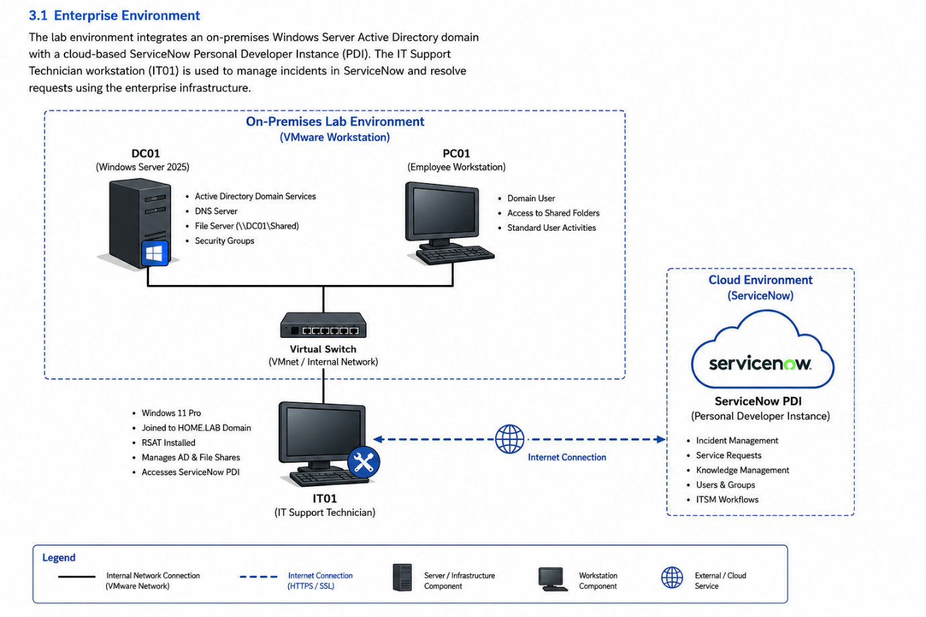

3.2 Support Workflow
Support requests are raised within ServiceNow before being assigned to the appropriate technician. The issue is investigated using Windows Server administration tools before the resolution is recorded within ServiceNow and the ticket is formally closed.

3.3 Project Workflow
The project follows a realistic enterprise support process consisting of:
- User reports an issue.
- Incident or service request created.
- Ticket categorised and prioritised.
- Investigation completed.
- Resolution performed within Active Directory.
- Resolution verified.
- Ticket closed.
- Knowledge article updated where appropriate.

4. Implementation
This section will document the complete implementation of the ServiceNow environment together with realistic IT support scenarios based on the Enterprise Active Directory Infrastructure Lab.

Step 1 – Create the IT Support Technician Workstation (IT01)
Purpose
The first stage of the project involved creating a dedicated Windows 11 Enterprise virtual machine to represent an IT Support technician's workstation. This workstation will be used throughout the project to access ServiceNow, investigate incidents, administer Active Directory remotely and manage user support requests.
Creating a separate technician workstation provides a realistic enterprise support environment by separating the IT administrator's workstation from the employee's computer and the Domain Controller.
Procedure
- Opened VMware Workstation Pro.
- Created a new virtual machine named IT01.
- Selected the Windows 11 Enterprise installation media.
- Configured the virtual machine hardware.
- Completed the Windows 11 installation.
- Confirmed the operating system booted successfully.
Verification
The Windows 11 Enterprise virtual machine was successfully created and booted into the desktop without errors. The workstation was ready for further configuration.

Implementation Evidence


Step 2 – Configure the IT Support Workstation
Purpose
Configure the IT Support workstation by installing essential software, applying system updates and preparing the environment for Active Directory administration and ServiceNow.
Procedure
- Renamed the computer to IT01 (if required).
- Installed VMware Tools.
- Installed Google Chrome.
- Checked for and installed Windows Updates.
- Verified internet connectivity.
- Confirmed the workstation was operating correctly.
Verification
The IT Support workstation was successfully configured and ready for further software installation and administration tasks.
Implementation Evidence
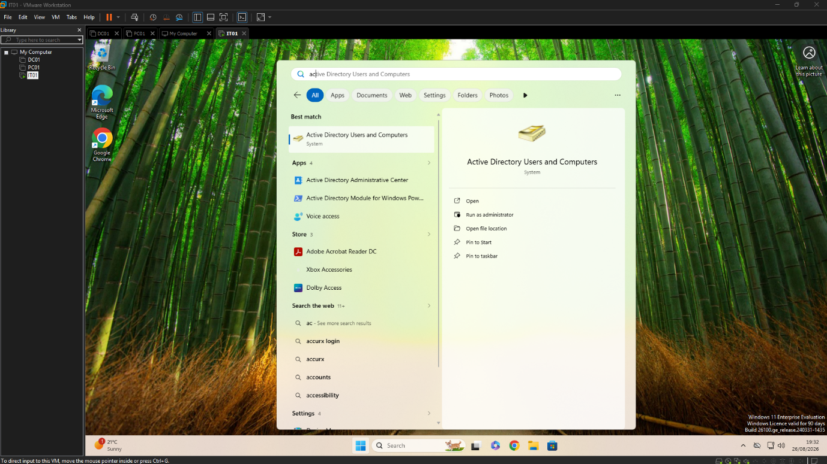

Step 3 – Join the IT Support Workstation to the Domain
Purpose
Join the IT Support workstation (IT01) to the Active Directory domain, enabling administrators to authenticate using domain credentials and remotely manage the enterprise environment from a dedicated workstation.
Procedure
- Verified network connectivity between IT01 and DC01.
- Opened the Windows system settings.
- Selected the option to join the Active Directory domain.
- Entered the domain name.
- Authenticated using domain administrator credentials.
- Restarted the workstation to apply the changes.
Verification
IT01 successfully joined the Active Directory domain. Domain user authentication was verified after restart and the workstation became a member of the enterprise domain.
Implementation Evidence
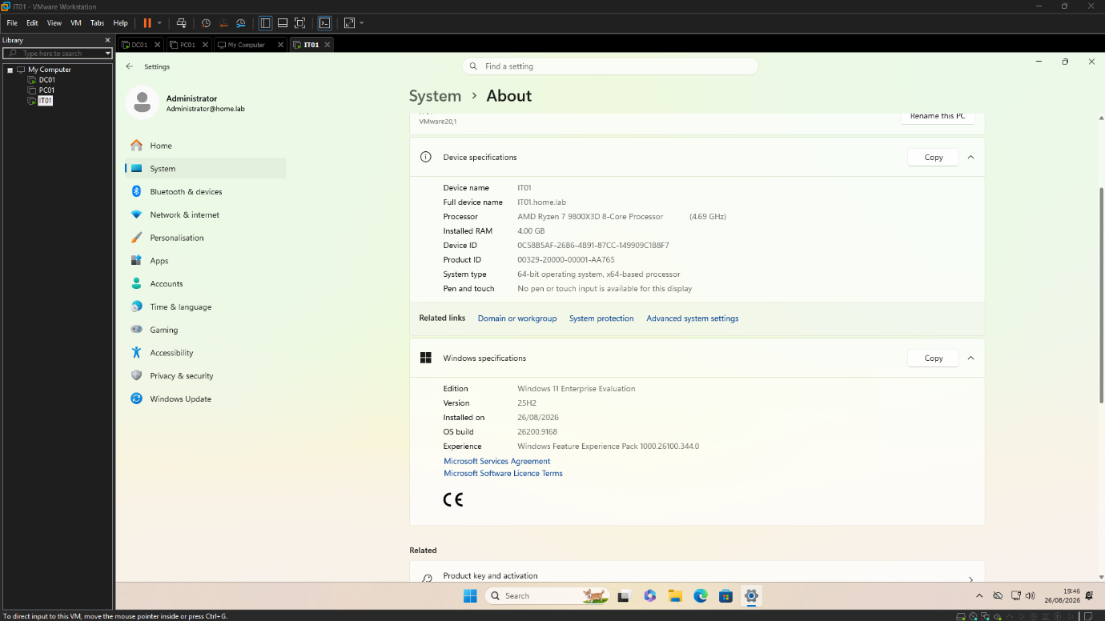

Step 4 – Create a ServiceNow Developer Account
Purpose
Create a ServiceNow Developer account to gain access to the ServiceNow Developer Program and obtain a Personal Developer Instance (PDI) for configuring and testing enterprise IT Service Management (ITSM) functionality.
Procedure
- Navigated to the ServiceNow Developer Portal.
- Registered a new ServiceNow Developer account.
- Verified the account using the registered email address.
- Successfully signed in to the Developer Portal.
Verification
The ServiceNow Developer account was successfully created and access to the Developer Portal was confirmed. The account was ready to request a Personal Developer Instance.
Implementation Evidence
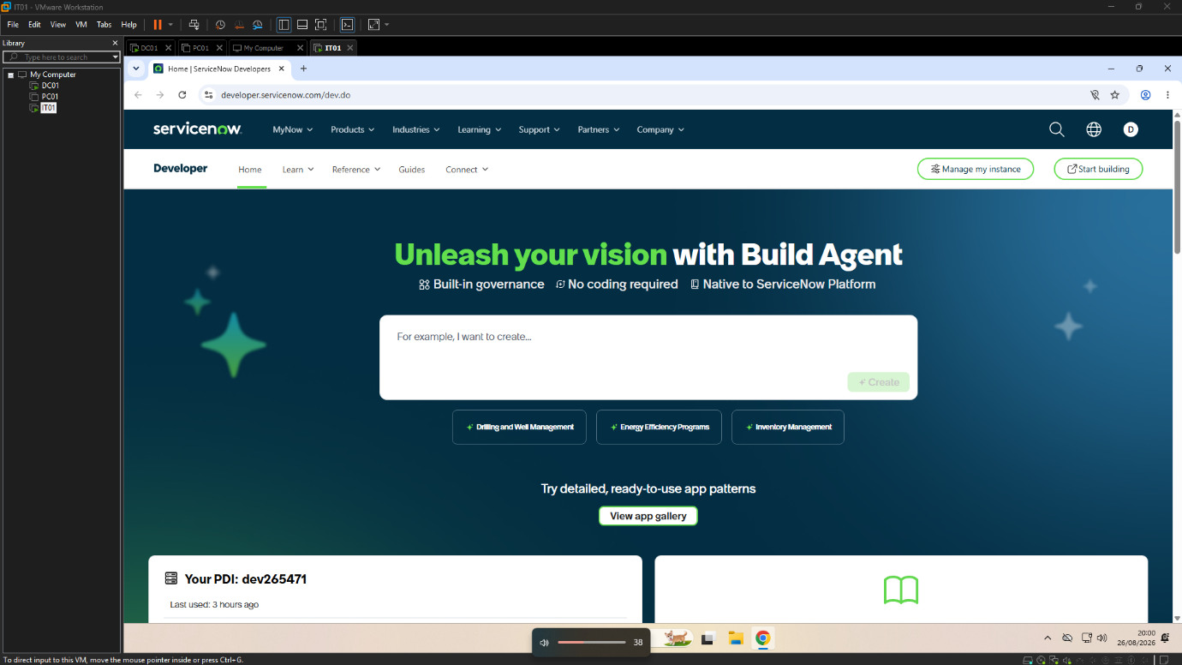

Step 5 – Request a Personal Developer Instance (PDI)
Purpose
Request a Personal Developer Instance (PDI) to provide a dedicated ServiceNow environment for configuring and testing enterprise IT Service Management (ITSM) functionality. The PDI serves as a sandbox where configurations and support scenarios can be developed without affecting production systems.
Procedure
- Accessed the Request Instance option from the ServiceNow Developer Portal.
- Selected the desired ServiceNow release.
- Submitted the request for a new Personal Developer Instance.
- Waited for the instance to be provisioned automatically.
- Recorded the instance URL and administrator credentials.
Verification
The Personal Developer Instance was successfully provisioned and was accessible using the administrator account provided by the ServiceNow Developer Program.
Implementation Evidence
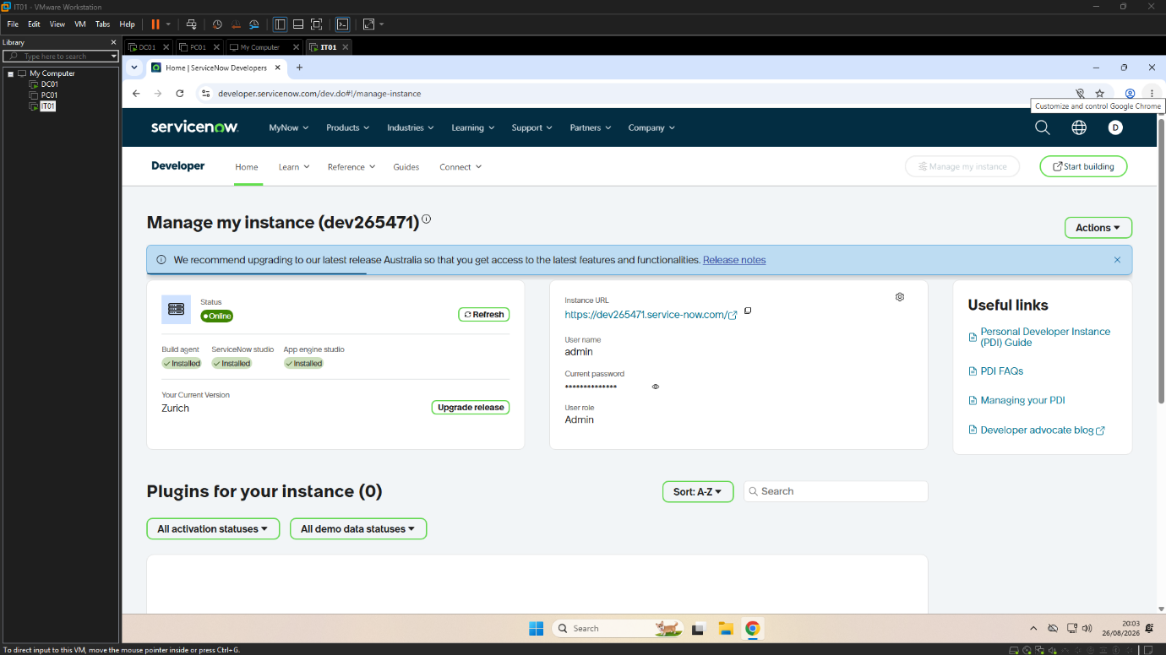

Step 6 – Access and Validate the ServiceNow Instance
Purpose
Access the newly provisioned ServiceNow Personal Developer Instance (PDI) and verify that the platform is operational before beginning the enterprise IT support configuration.
Procedure
- Opened the ServiceNow Personal Developer Instance using the instance URL.
- Signed in using the administrator account.
- Verified successful authentication.
- Confirmed the default ServiceNow homepage loaded successfully.
- Verified access to the Application Navigator and administrator interface.
Verification
The ServiceNow Personal Developer Instance was successfully accessed and the administrator account was authenticated. The environment was confirmed to be operational and ready for configuration.
Implementation Evidence
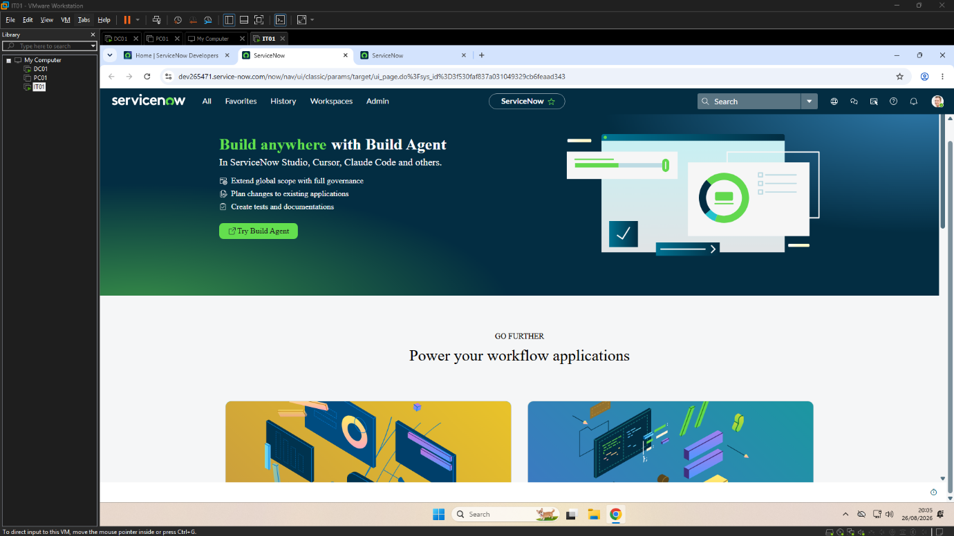

Step 7 – Familiarise with the ServiceNow Interface
Purpose
Review the ServiceNow interface and identify the key modules used by IT Support technicians for incident management, user administration and service request fulfilment before beginning practical support activities.
Procedure
- Signed in to the ServiceNow Personal Developer Instance.
- Explored the Application Navigator.
- Reviewed the Incident, Users and Knowledge modules.
- Verified access to the Service Desk interface.
- Confirmed the platform was ready for enterprise IT support activities.
Verification
The ServiceNow environment was successfully accessed and the key modules required for the remainder of the project were available and functioning correctly.
Implementation Evidence
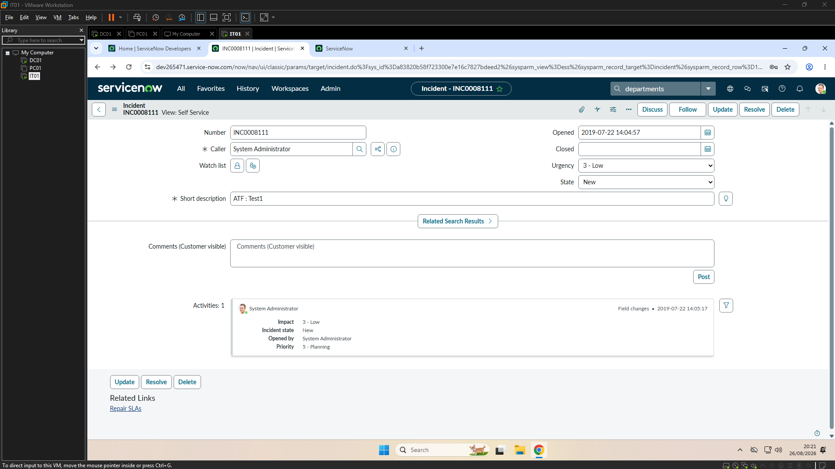

5. IT Support Scenarios
This section documents a series of realistic IT support scenarios completed using the ServiceNow Personal Developer Instance together with the Enterprise Active Directory Infrastructure Lab. Each scenario follows the complete incident management lifecycle from ticket creation through investigation, resolution, verification and closure.

5.1 Incident INC0010006 – User Unable to Sign In
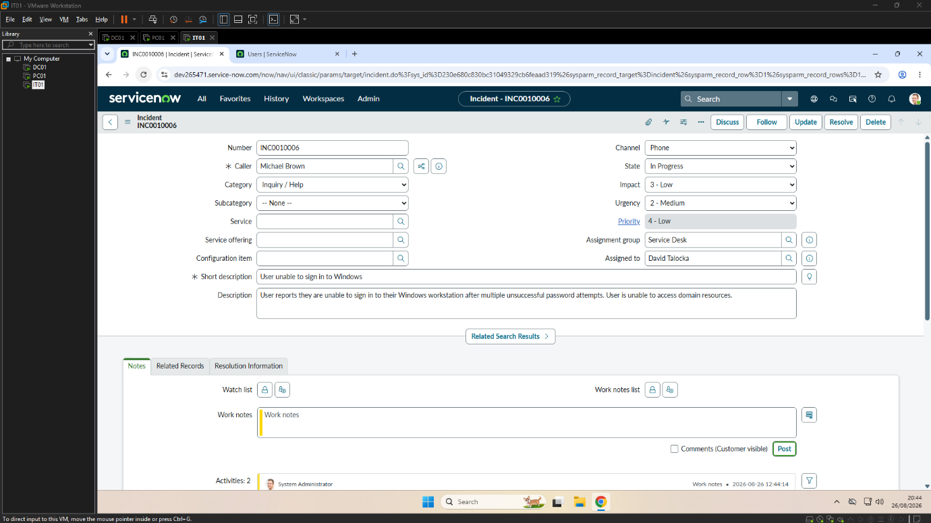
Incident Summary
Michael Brown contacted the IT Service Desk after being unable to sign in to his Windows workstation. Following multiple unsuccessful password attempts, the user's Active Directory account became locked, preventing access to domain resources.
Investigation
Purpose
Determine the cause of the authentication failure and restore the user's access.

Procedure
- Reviewed the incident details in ServiceNow.
- Changed the incident state from New to In Progress.
- Recorded initial work notes.
- Opened Active Directory Users and Computers from the IT01 workstation.
- Located Michael Brown's user account.
- Confirmed the account was locked following multiple failed sign-in attempts.
Verification
The account lockout was confirmed as the cause of the authentication issue.
Implementation Evidence
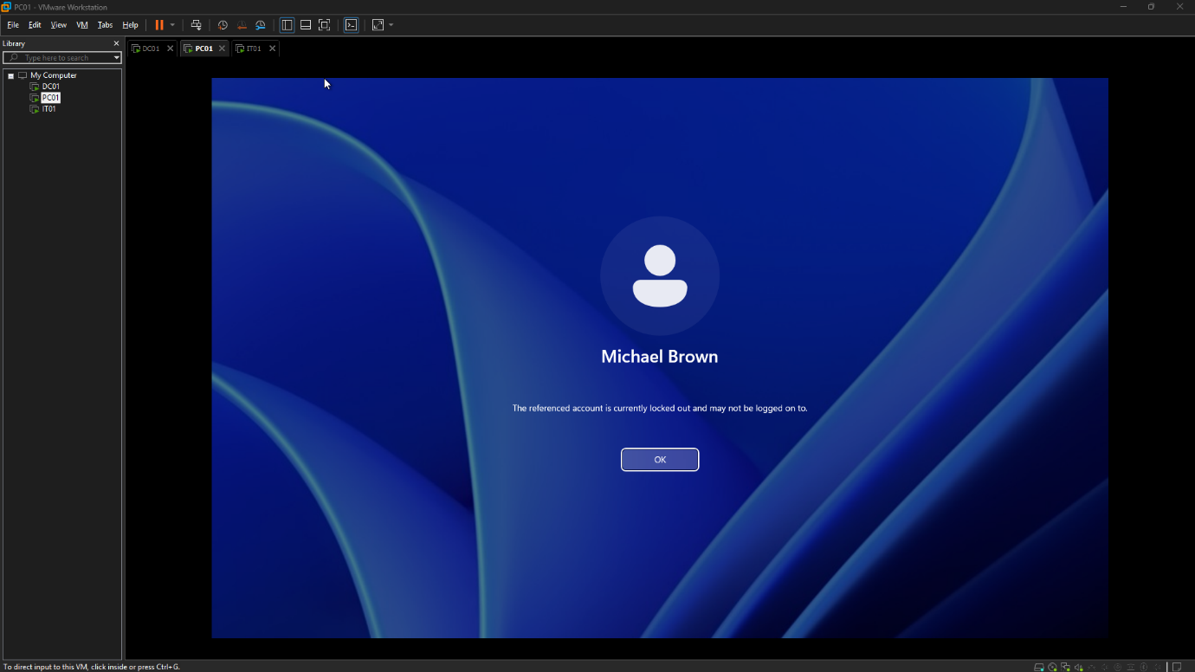
Resolution
Purpose
Restore user access and complete the incident.

Procedure
- Unlocked the Active Directory account.
- Requested the user to attempt another sign-in.
- Verified successful authentication.
- Updated the incident with the resolution.
- Changed the incident state to Resolved.
- Closed the incident after user confirmation.
Verification
Michael Brown successfully authenticated to the domain and confirmed that access to the Windows workstation had been restored.
Implementation Evidence
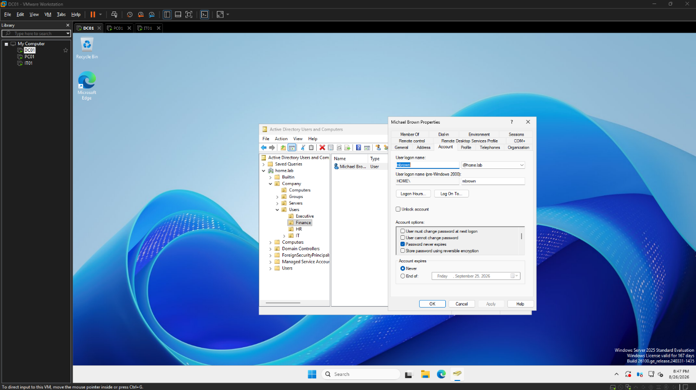
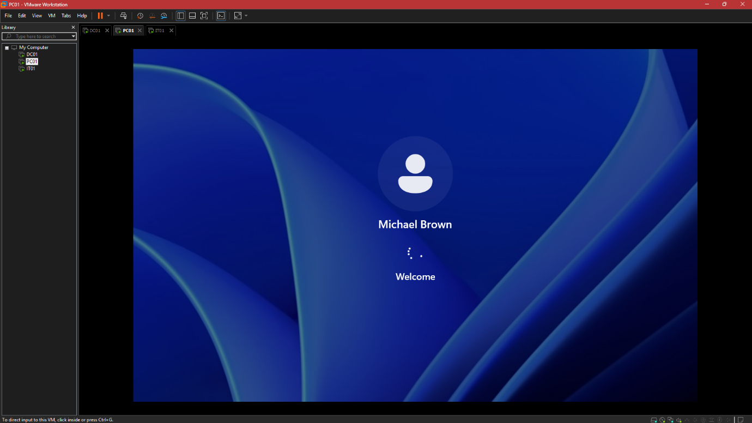
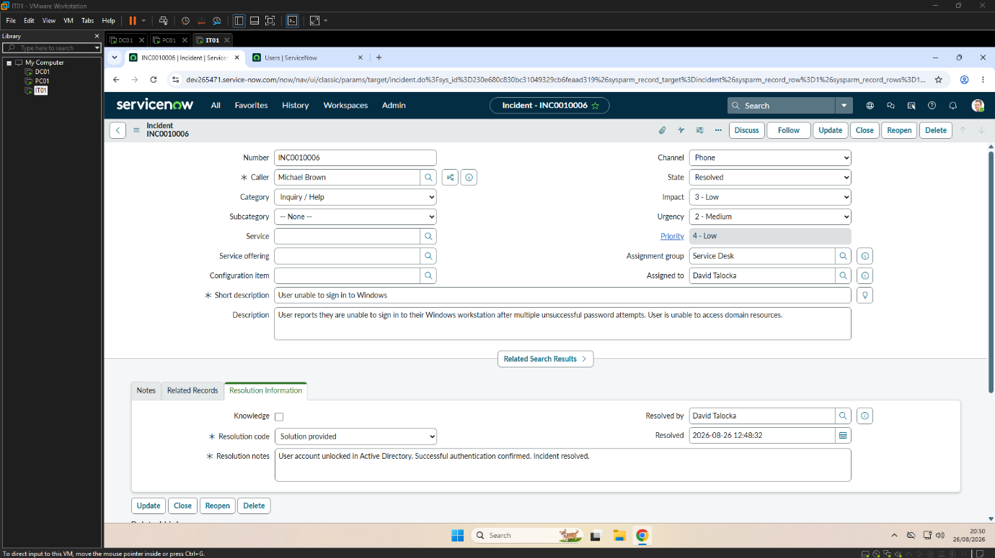

5.2 Incident INC0010008 – Password Reset
Incident Summary
Emma Wilson contacted the IT Service Desk after forgetting her Windows password and was unable to sign in to her workstation. Following identity verification, the incident was logged in ServiceNow and assigned to the IT Support team. The password was reset in Active Directory and the user successfully signed in using a new password.
Investigation
Purpose
Investigate the reported authentication issue and determine the appropriate action to restore the user's access.
Procedure
- Reviewed the incident details in ServiceNow.
- Changed the incident state to In Progress.
- Verified the user's identity.
- Confirmed that a password reset was required.
Verification
The issue was confirmed to be a forgotten password requiring a password reset.
Implementation Evidence
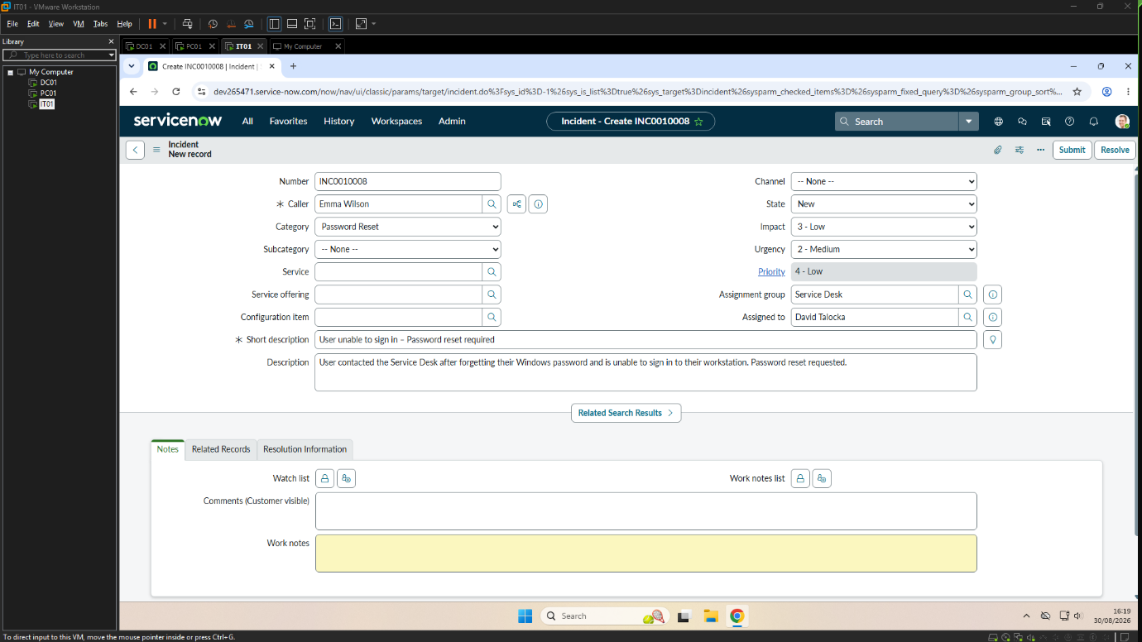
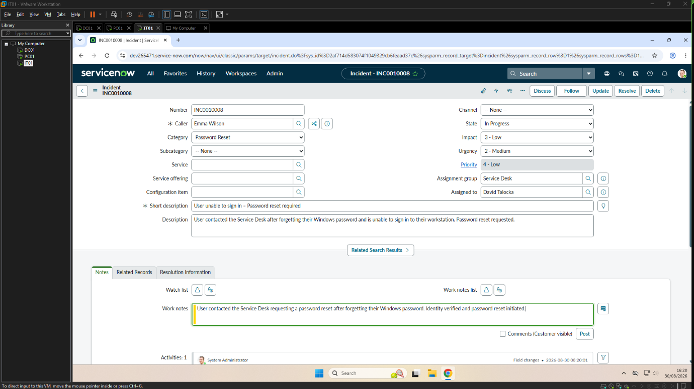
Resolution
Purpose
Reset the user's password and restore access to the domain.
Procedure
- Opened Active Directory Users and Computers.
- Located the Emma Wilson account.
- Reset the password.
- Selected User must change password at next logon.
- Provided the temporary password to the user.
- Confirmed successful sign-in and password change.
- Updated the ServiceNow incident.
- Resolved and closed the ticket.
Verification
The user successfully signed in using the new password and confirmed access had been restored.

Implementation Evidence
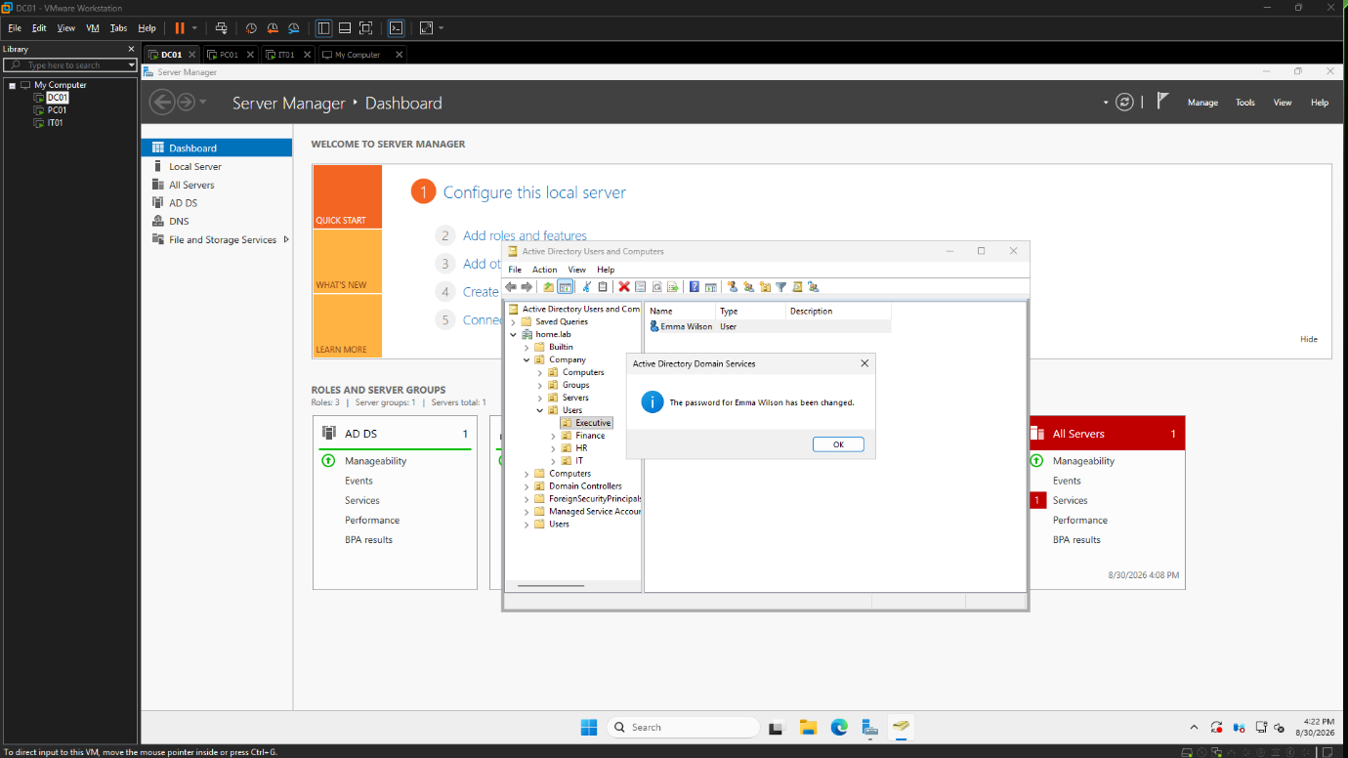
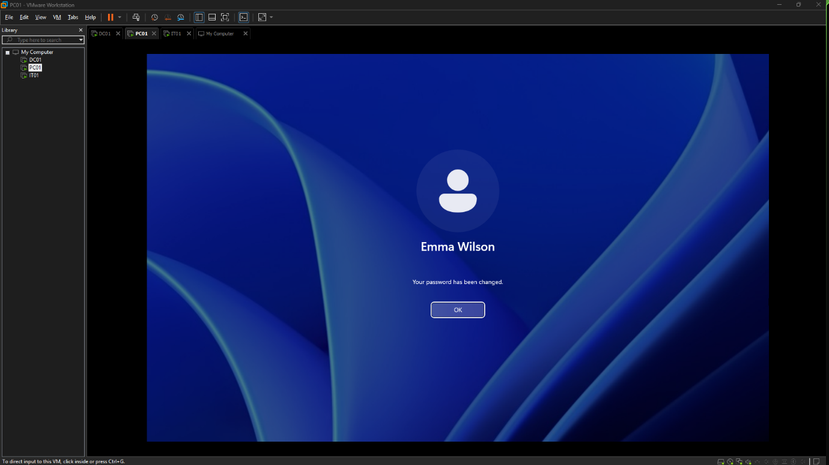
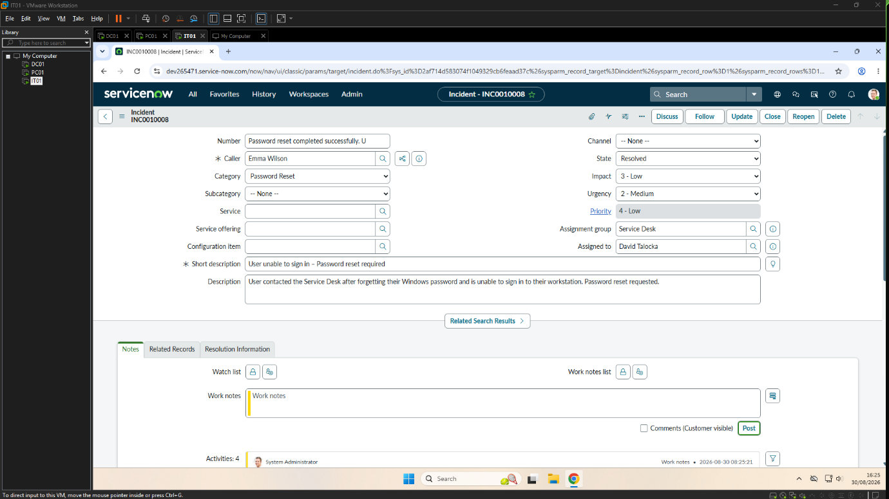

5.3 Incident INC0010010 – Shared Folder Access
Incident Summary
Sarah Jones from the Human Resources department contacted the IT Service Desk after receiving an Access Denied message when attempting to access the HR network share. The incident was logged in ServiceNow and investigated by the IT Support team. The issue was traced to incorrect sharing permissions on the network share. After restoring the required permissions, access was successfully verified and the incident was resolved.
Investigation
Purpose
Investigate the reported access issue and determine why the user was unable to access the HR network share.
Procedure
- Reviewed the incident details in ServiceNow.
- Changed the incident state to In Progress.
- Reviewed the HR shared folder configuration.
- Confirmed the reported Access Denied behaviour.
- Identified incorrect sharing permissions on the network share.
Verification
The issue was confirmed to be caused by incorrect sharing permissions on the HR network share.
Implementation Evidence
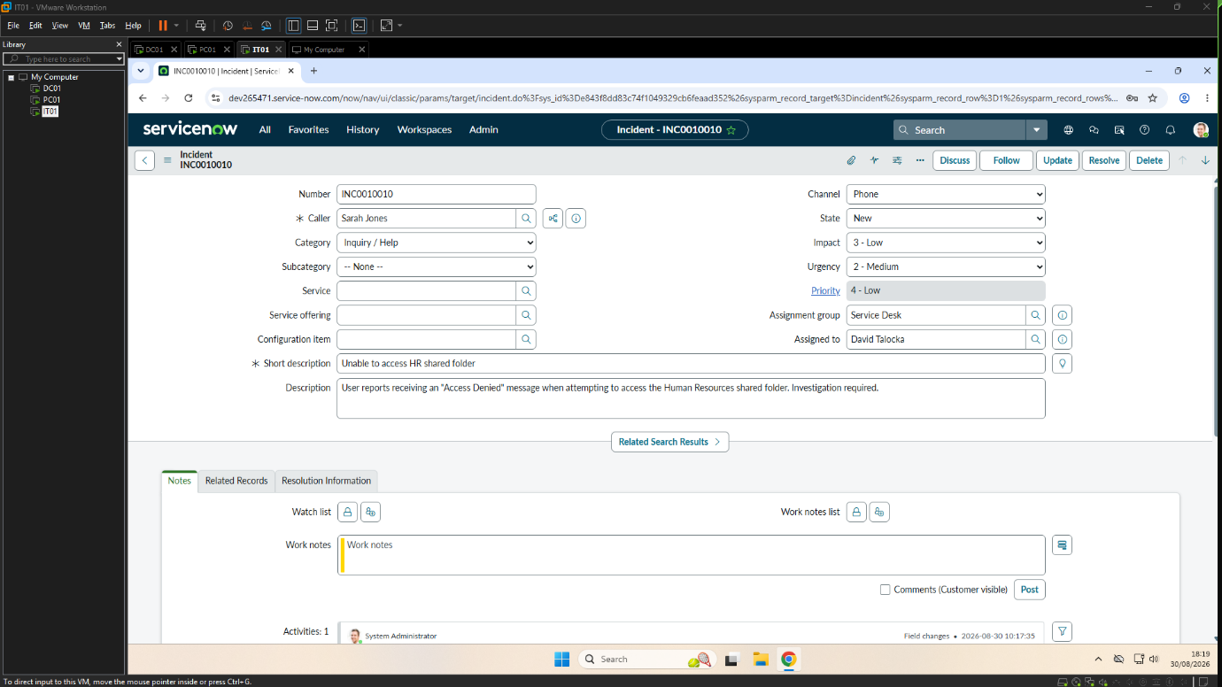
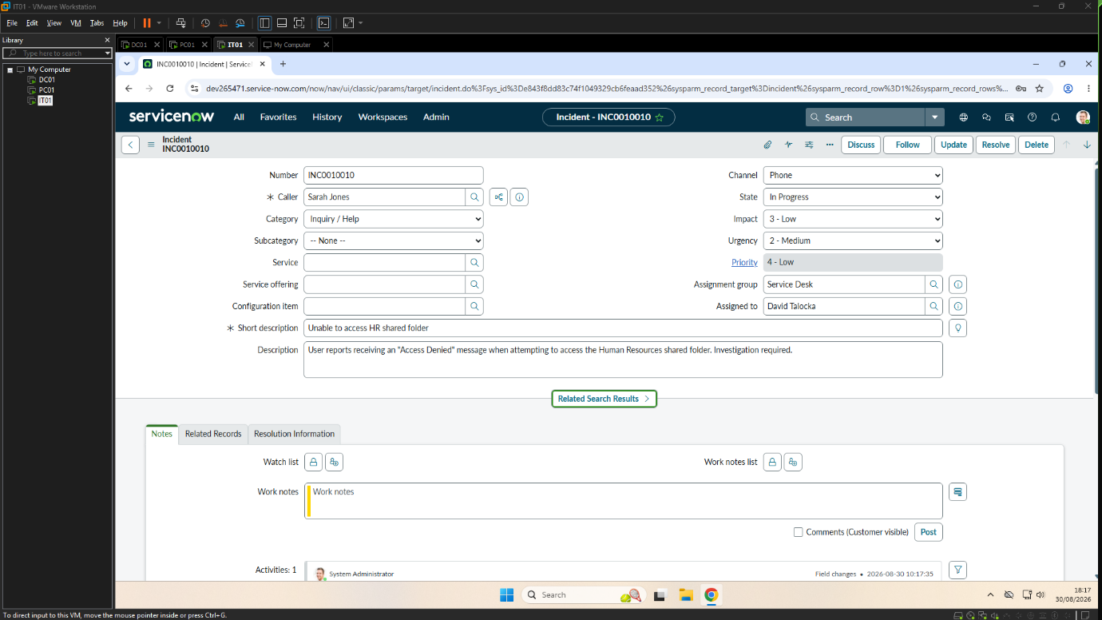
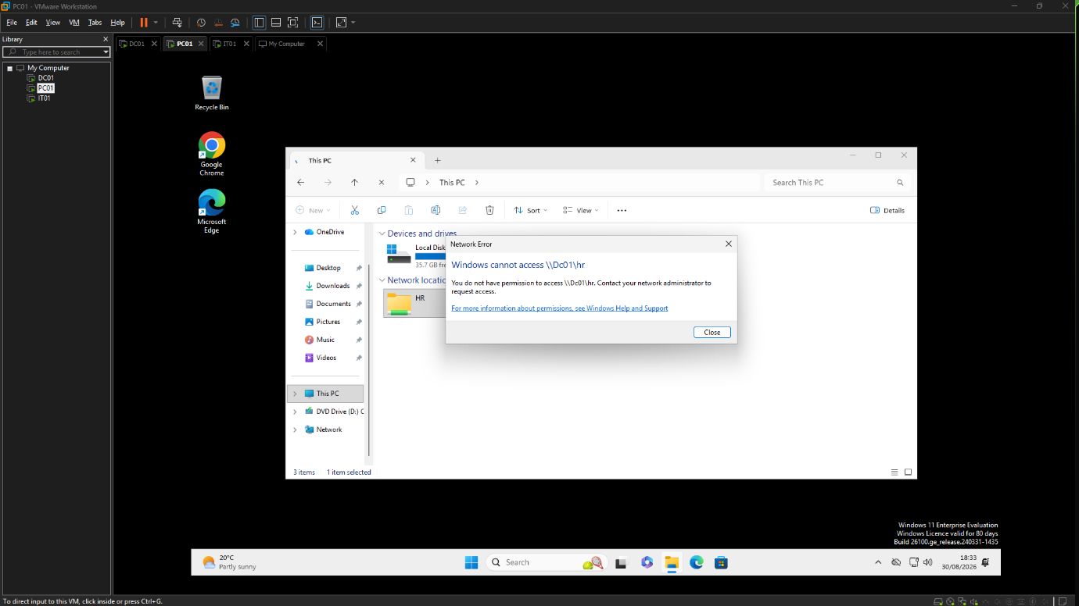
Resolution
Purpose
Restore access to the HR network share by correcting the sharing permissions.
Procedure
- Opened the HR folder properties.
- Reviewed the sharing configuration.
- Restored the required sharing permissions.
- Verified that the user could successfully access the shared folder.
- Updated and resolved the ServiceNow incident.
Verification
The user successfully accessed the HR network share after the sharing permissions were restored.
Implementation Evidence
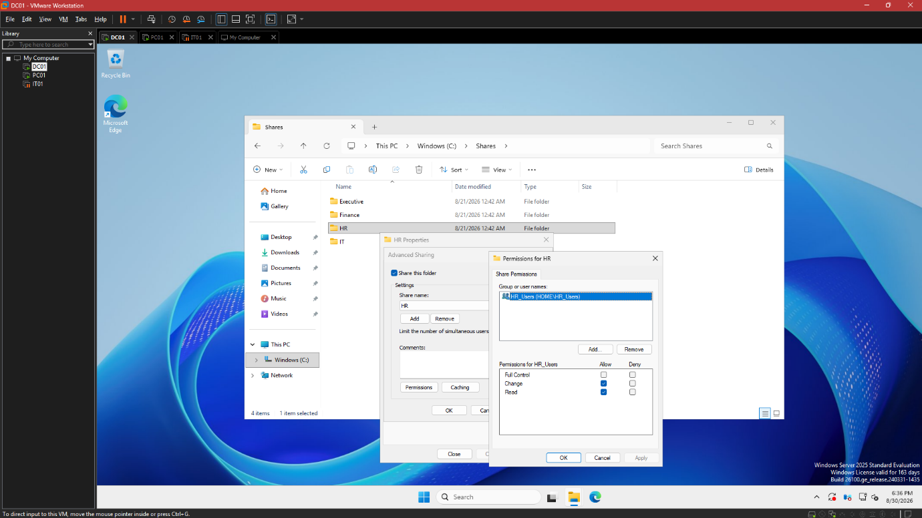
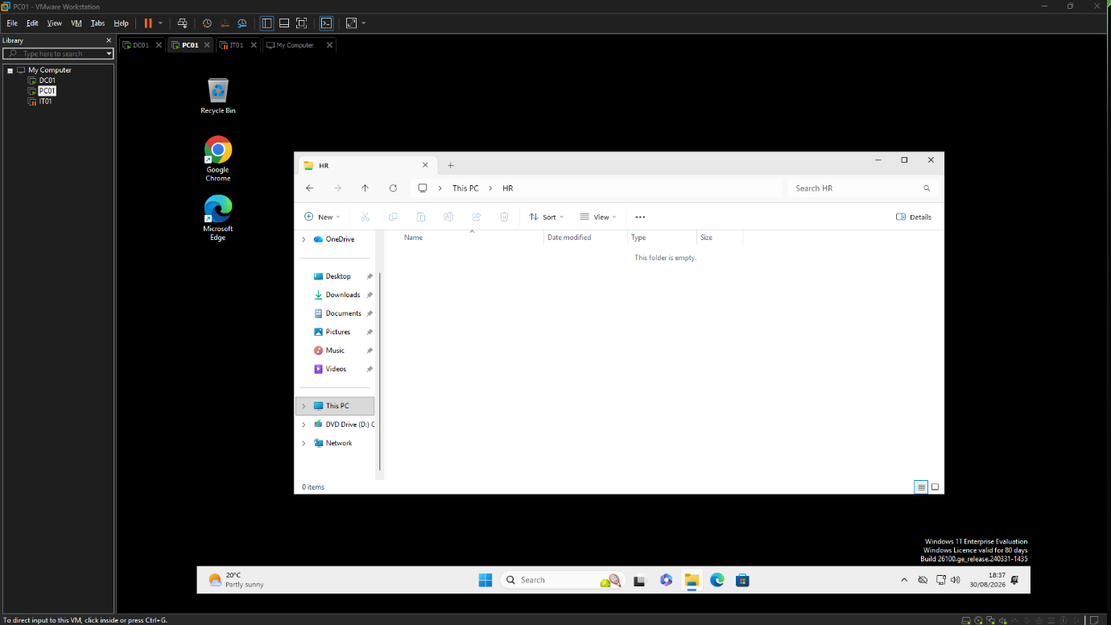
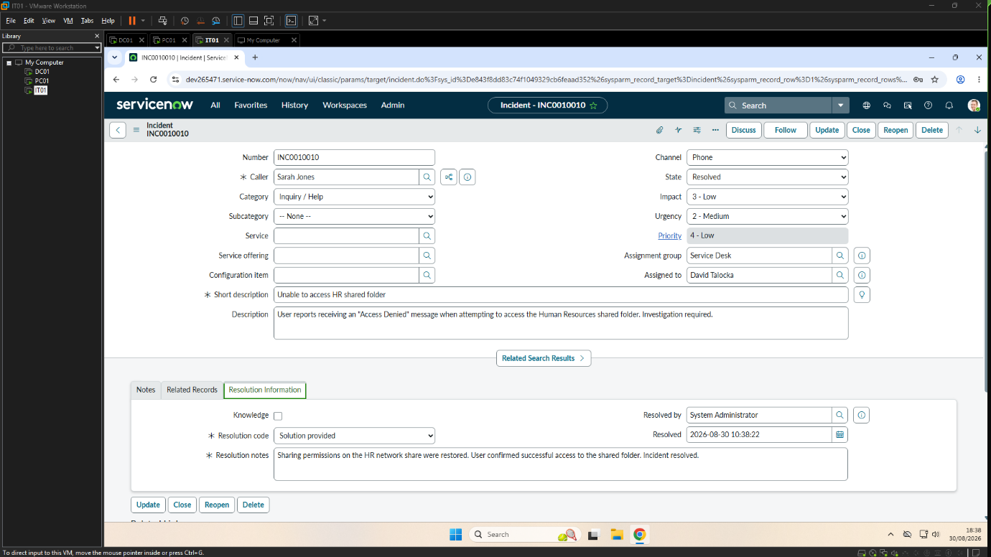

5.4 Incident INC0010012 – New User Account Creation
Incident Summary
The Human Resources department contacted the IT Service Desk requesting the creation of a new Active Directory domain account for Daniel Carter, a new employee joining the Finance department. The request was reviewed and the required user account was created, configured and assigned the appropriate departmental access before the incident was resolved.
Investigation
Purpose
Review the request for a new domain user account and confirm the information required to provision the account.
Procedure
- Reviewed the incident submitted by Human Resources.
- Verified the employee's department and required account details.
- Confirmed the appropriate organisational unit and security group assignments.
- Prepared the account creation process.
Verification
The information required to create the new domain account was verified before the account was provisioned.
Implementation Evidence
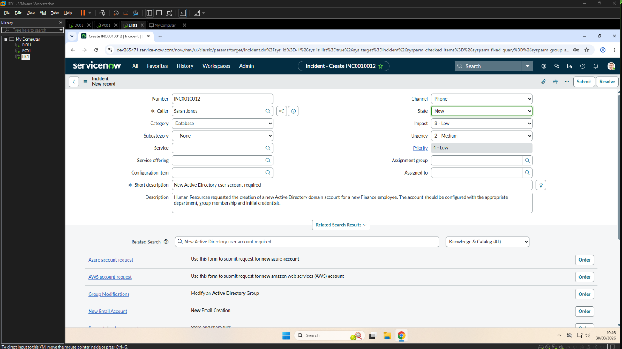
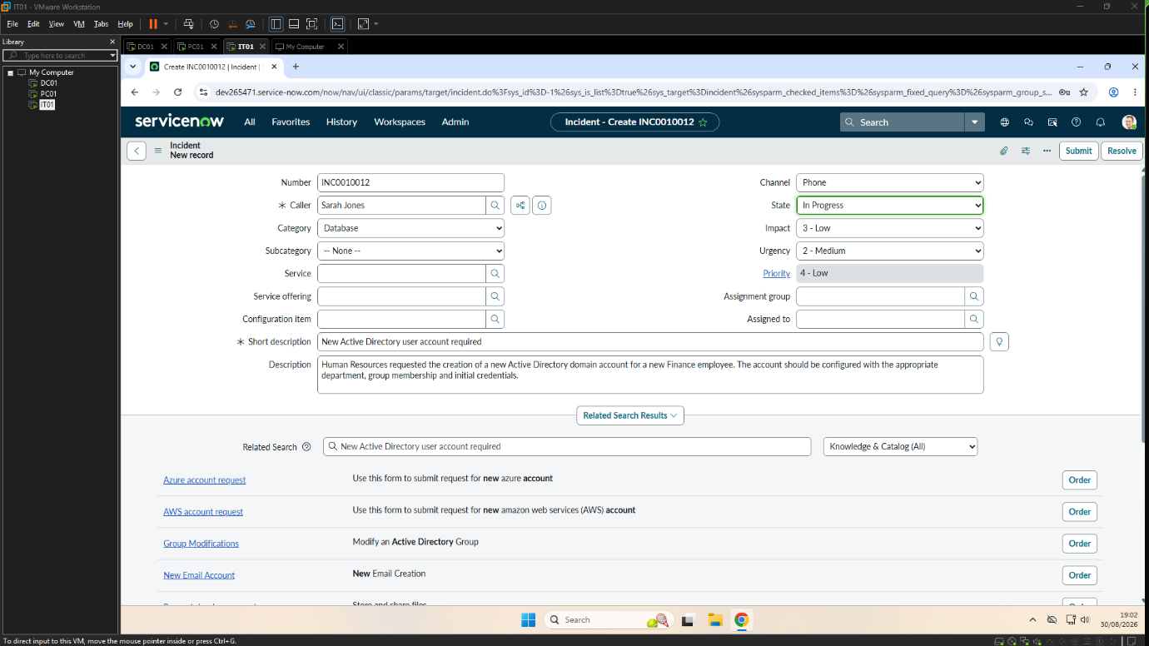
Resolution
Purpose
Provision a new Active Directory domain account for the employee and assign the required departmental access.

Procedure
- Created the new user account in Active Directory.
- Configured the user's initial password.
- Enabled User must change password at next logon.
- Added the user to the Finance_Users security group.
- Verified the account was successfully created within the Finance organisational unit.
- Confirmed the user could successfully sign in to the domain.
- Updated and resolved the ServiceNow incident.
Verification
The new Active Directory domain account was successfully provisioned, assigned the required Finance security group membership and verified through a successful first domain sign-in.
Implementation Evidence
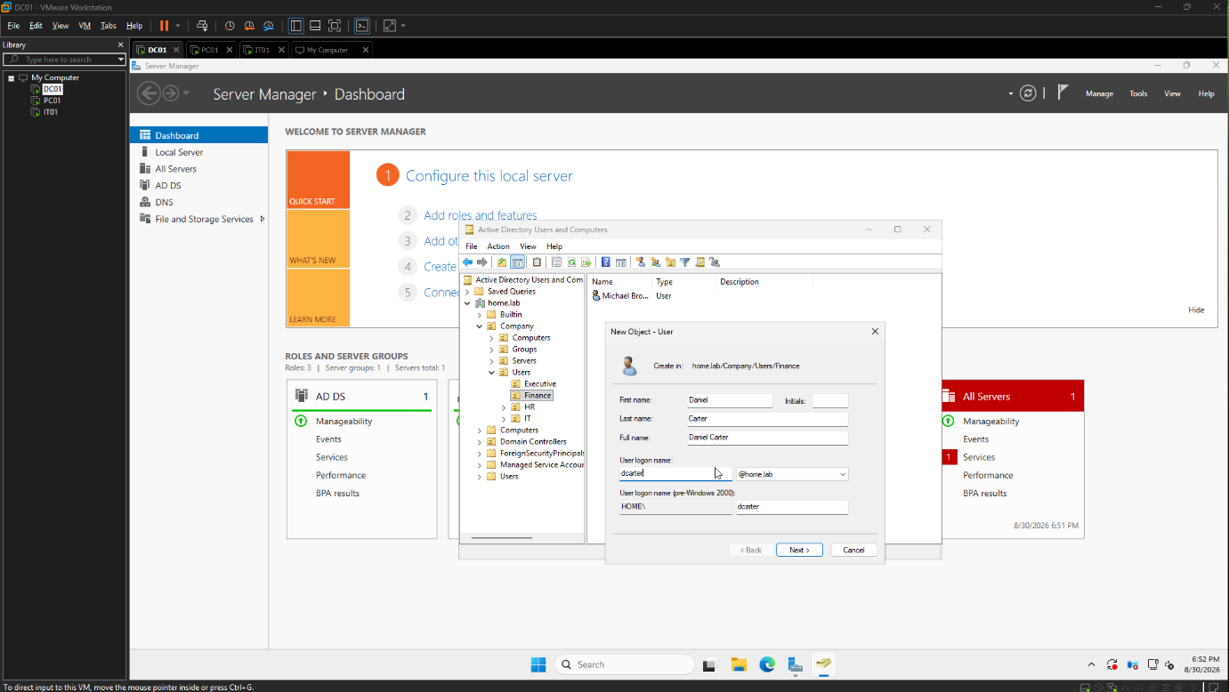
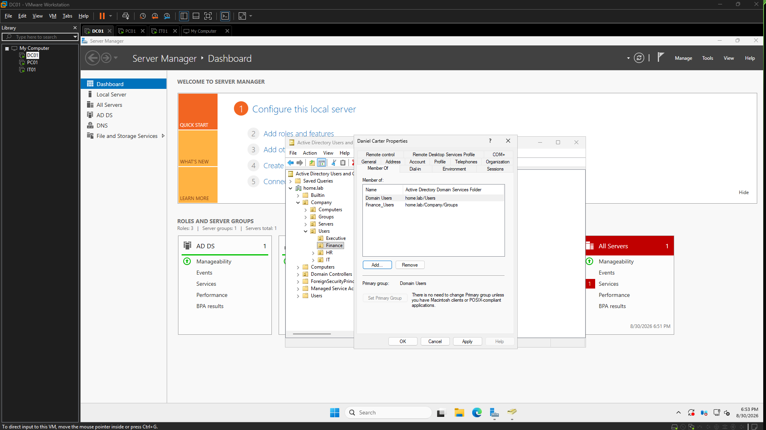
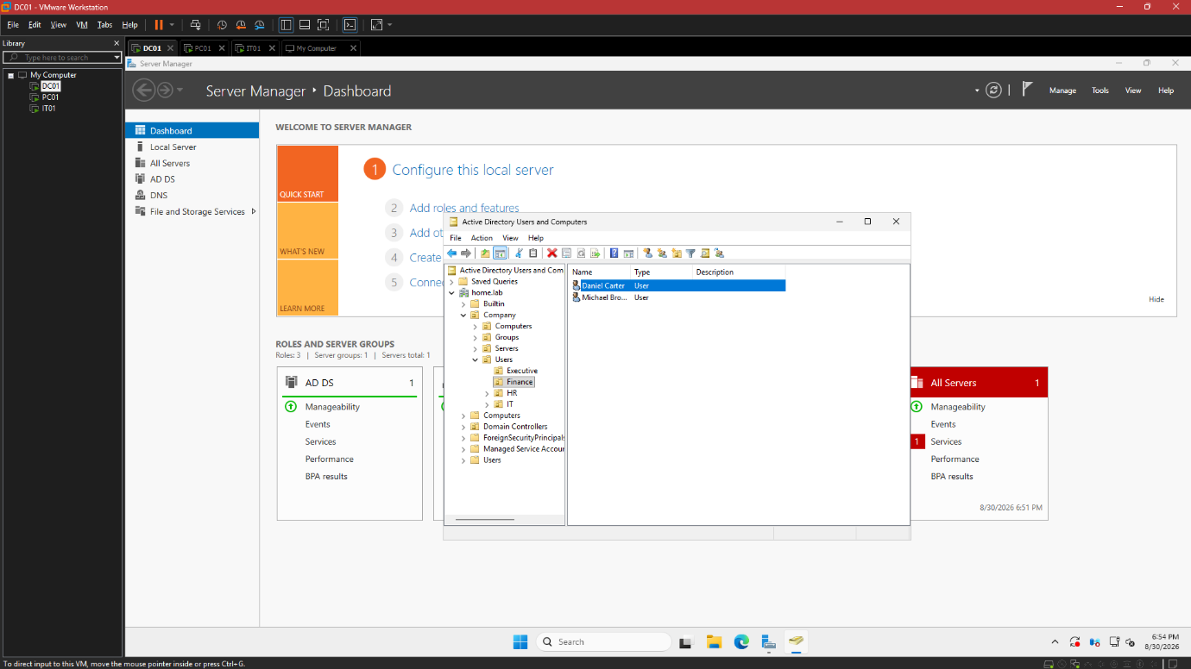

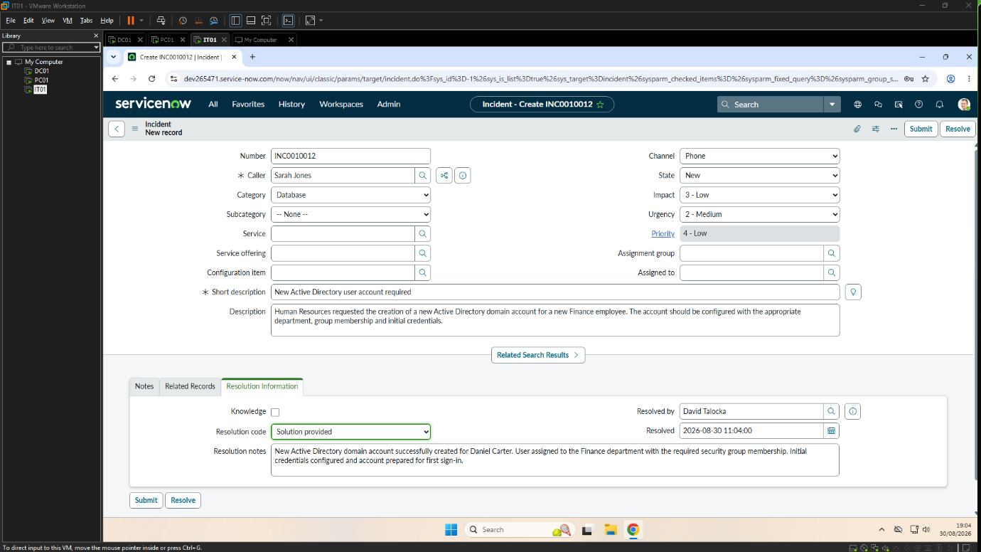

5.5 Incident INC0010013 – Software Installation
Incident Summary
Michael Brown from the Finance department contacted the IT Service Desk requesting the installation of 7-Zip to enable the extraction of compressed project files. The software was not available on the user's workstation. The request was investigated, the application was installed successfully and functionality was verified before the incident was resolved.
Purpose
Investigate the user's software request and confirm that the required application was not installed on the workstation.
Procedure
- Reviewed the incident details in ServiceNow.
- Changed the incident state to In Progress.
- Verified the user's software requirements.
- Confirmed that 7-Zip was not available on the workstation.
- Approved the software installation.
Verification
The workstation was confirmed to require the installation of 7-Zip before the user could access compressed files.
Implementation Evidence
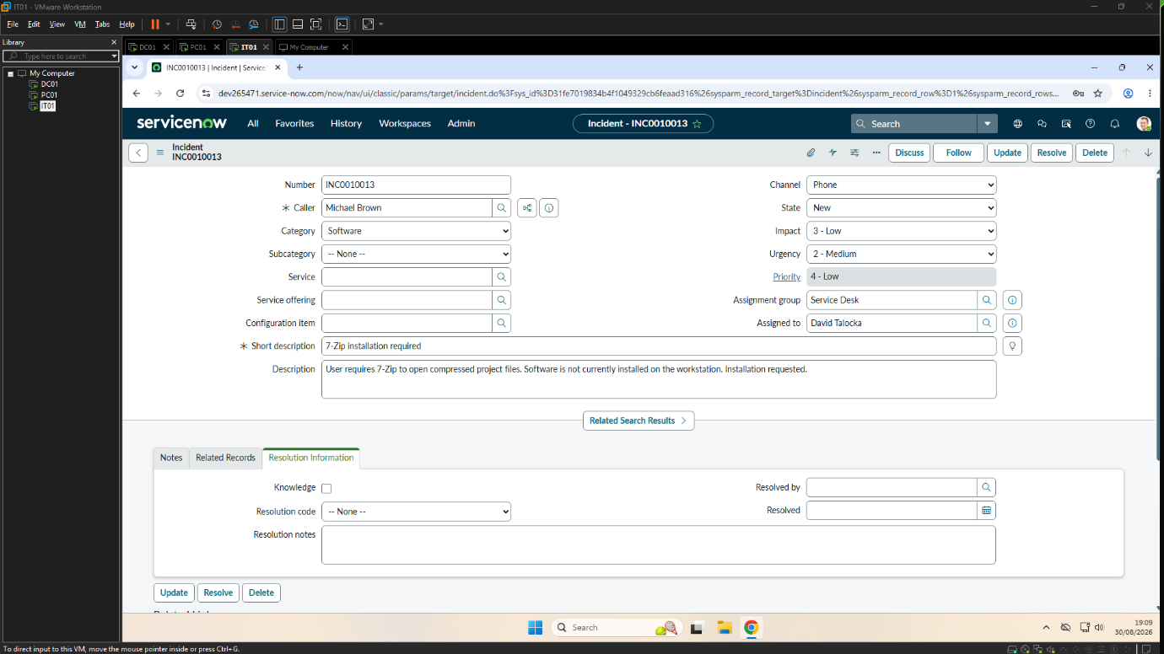
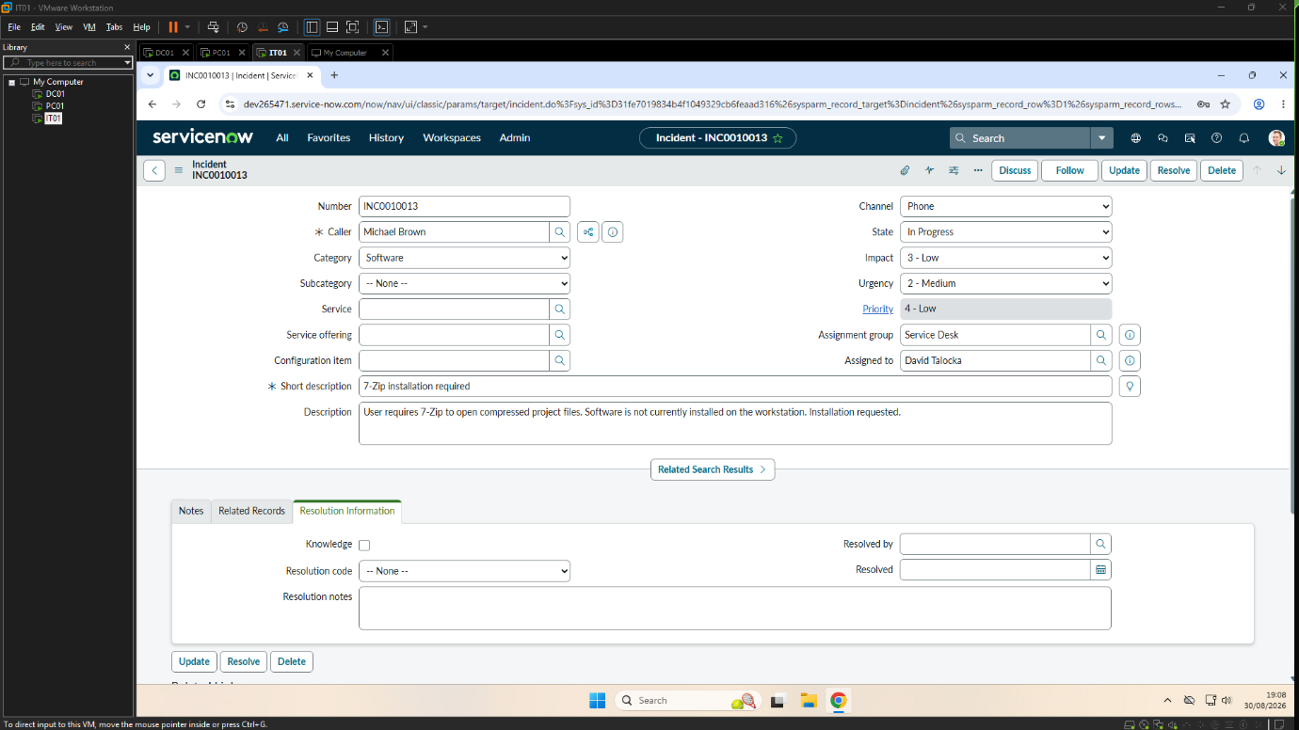
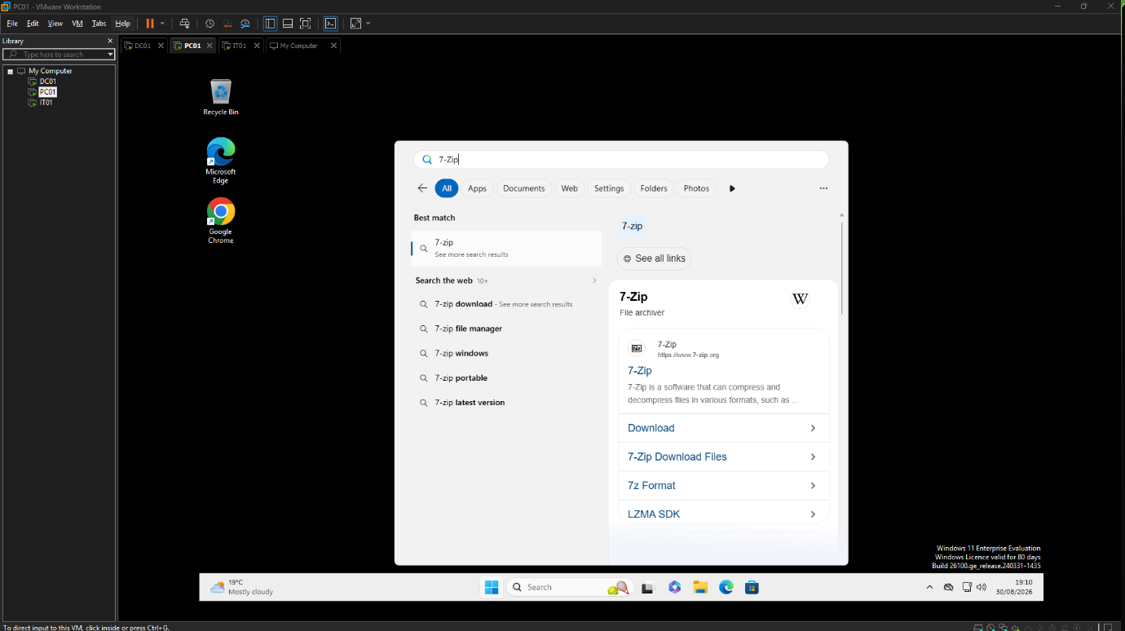
Resolution
Purpose
Install the requested software and verify that it was successfully deployed to the user's workstation.
Procedure
- Downloaded the latest version of 7-Zip.
- Installed the application using the default installation settings.
- Verified that the installation completed successfully.
- Confirmed that 7-Zip was correctly integrated into the Windows context menu.
- Updated and resolved the ServiceNow incident.
Verification
The software installation completed successfully, and 7-Zip was verified to be operational through the Windows Explorer context menu, confirming that the application had been installed correctly and was available for user access.

Implementation Evidence
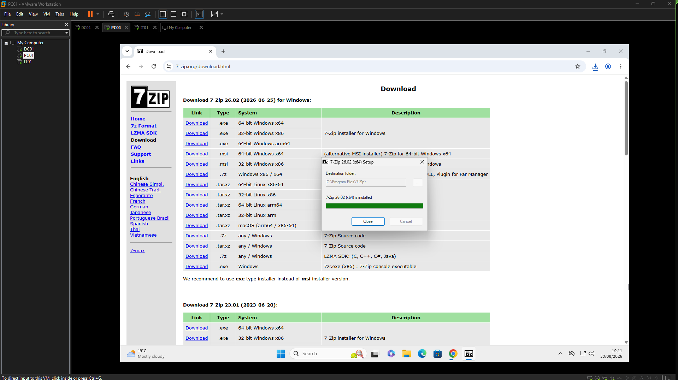
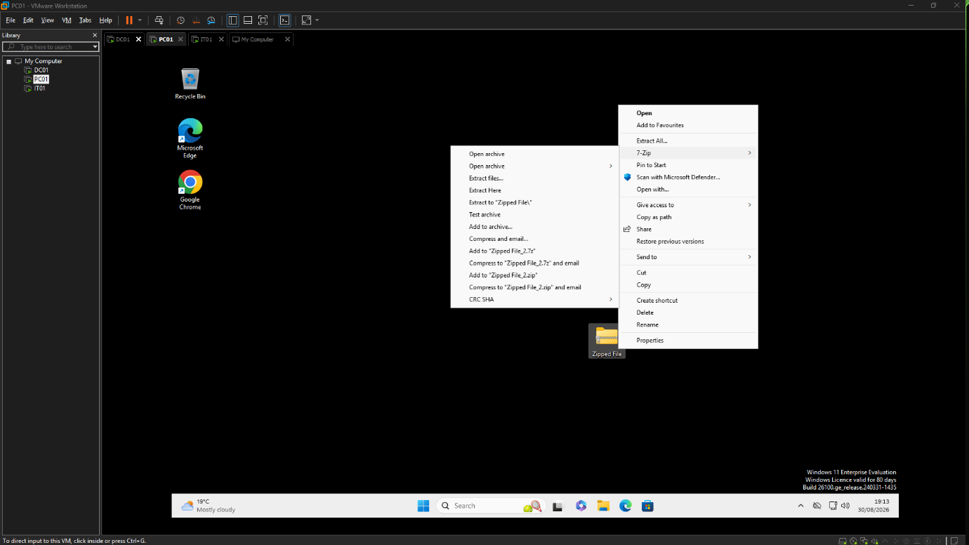
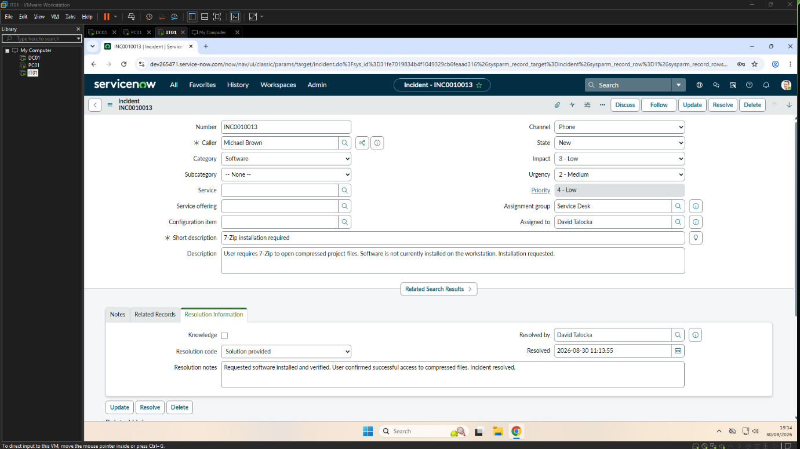

6. Knowledge Management
Overview
To support consistent service delivery, a knowledge article was created documenting the standard process for creating a new Active Directory user account. The article provides IT technicians with a repeatable procedure for provisioning new domain users, helping to improve consistency and reduce onboarding time.
Implementation Evidence
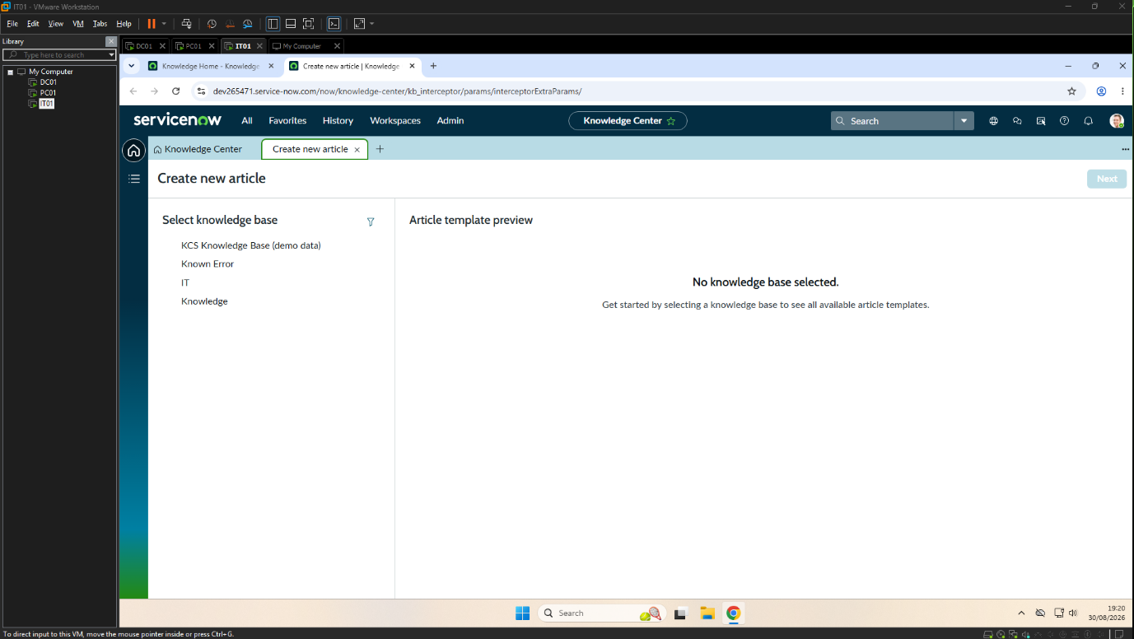
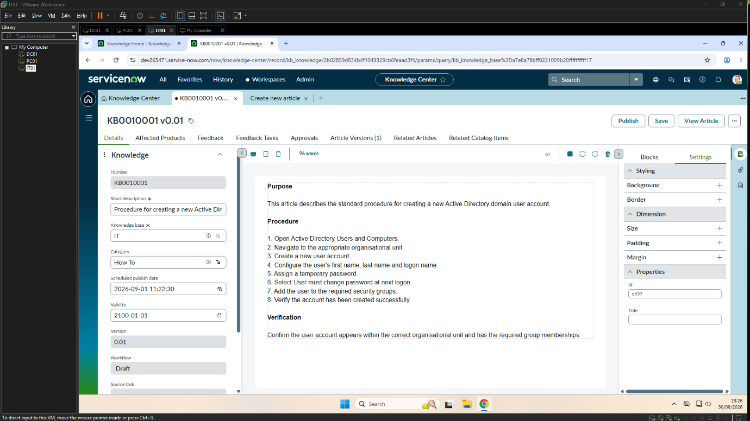

7. Conclusion
Overview
This project successfully demonstrated the implementation of an enterprise-style IT support environment using ServiceNow and Microsoft Active Directory. A range of common IT support tasks were completed using structured incident management processes, including account management, password administration, shared folder access, user provisioning and software installation.
Each incident followed a consistent workflow consisting of investigation, implementation and verification, with supporting evidence recorded throughout the project. A knowledge article was also created to demonstrate the importance of maintaining documentation and supporting future incident resolution.
Overall, this project strengthened practical experience with ServiceNow, Active Directory and Windows administration while reinforcing the value of structured troubleshooting, accurate documentation and professional IT support practices.

8. Lessons Learned
Throughout this project, valuable practical experience was gained in managing common IT support scenarios within an enterprise environment.
Key lessons learned include:
- Applying the complete incident management lifecycle using ServiceNow.
- Creating and managing Active Directory domain user accounts.
- Troubleshooting authentication and account-related issues.
- Managing shared folder permissions and user access.
- Performing software installation and post-installation verification.
- Producing technical documentation supported by implementation evidence.
- Following consistent troubleshooting and verification procedures before resolving incidents.
- Understanding the importance of knowledge management in supporting efficient IT service delivery.
Completing this project also reinforced the importance of clear communication, accurate record keeping and structured problem-solving when supporting users within a Windows domain environment.

